 |  | 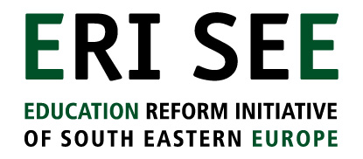
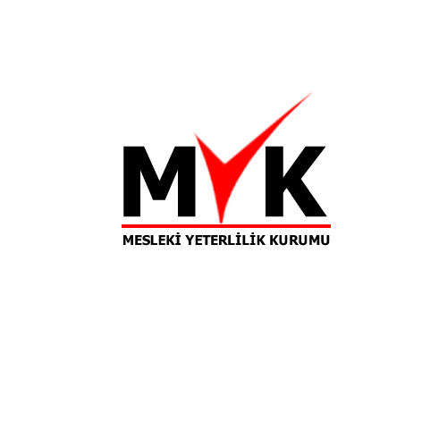

implementing nqfs - Growing bamboo trees?

Implementing National Qualifications Frameworks takes time before the results are becoming visible

Implementation creates many specific challenges

Lessons from and for South Eastern Europe

On the 17-18 December 2008 ETF organised together with the Vocational Qualifications Authority in Turkey (MYK) and the Education Reform Initiative for South Eastern Europe (ERISEE) a conference on implementation strategies for national qualifications frameworks in South Eastern Europe. The implementation strategy of VQA was central to the conference that focused as well on how to ensure the active involvement of sectors in NQFs, how to strengthen quality assurance, assessment and certification processes and how to develop sustainable structures and finance national qualification frameworks. The development of the NQF was compared to growing a bamboo tree in one of the opening speeches; you need to water the seeds for several years before the plant starts to grow.

 | The analogy of the Chinese Bamboo Tree: After the seed for this amazing tree is planted, you see nothing, absolutely nothing, for four years except for a tiny shoot coming out of a bulb. During those four years, all the growth is underground in a massive, fibrous root structure that spreads wide and deep in the earth. But then in the following year, the Chinese bamboo tree grows up to eighty feet! From this we learn the virtue of patience and a deeper appreciation of everlasting success.

Moving from hidden to open strategies for implementation

Turkey is ahead of most of the countries in South Eastern Europe as it has already adopted a law on a Qualifications Framework in 2006 and has established a Vocational Qualifications Authority that became operational this year. But all the countries of South Eastern Europe are making progress in establishing National Qualifications Frameworks. This is important progress from when ETF started to work with them in 2003 on raising awareness on NQFs the questions were still more about what these NQFs were and what they could mean for the countries.

The implications of these developments are now becoming clearer. Discussions have taken place, why the countries need NQFs. National strategies have been adopted and laws have been developed or are under development. The thinking about the national framework is addressing more operational and practical issues.

All NQFs are different and the development process goes through different stages that raise different type of issues.

Most countries in South Eastern Europe only started to consider the development of NQFs five years ago. The orientation phase at the time focused on what NQFs where and what the implications of having a NQF could be. Things have progressed very much since then. Most countries have tried to conceptualise their frameworks, developing a national rationale and identifying key stakeholders. National strategies have been developed and legislation is progressing in many countries. But the objectives of national qualifications frameworks are often not always associated with resolving specific national issues. The NQF is rather seen as an instrument that is part of the European integration process. Belonging to Europe implies for many countries that they are able to compare national standards to European ones. That is why officials meeting in January 2008 from some countries still asked themselves how they could fit their existing education and training systems into the eight-level framework of the EQF.

Most countries have already moved on from conceptualisation to the design of a national framework. NQFs are close to becoming a reality in the region, as laws have developed, implementing bodies are being nominated and sectoral bodies are being set up. More and more people understand the NQF terminology, but we are still far from fully functional frameworks.

Exploring critical issues

Once countries move closer to implementation specific problems occur around how to organise the framework, how to develop and sustain new structures, how to strengthen confidence in the new frameworks. This has been the focus of the conference. Three critical issues for implementation were discussed in-depth between representatives from the emerging qualifications agencies and other relevant national bodies:

- How to develop sectoral approaches?
- What are the implications for assessment and certification processes?
- How to ensure sustainable structures and funding for the implementation of the NQF?

The discussions were inspired by the opening statements of different highly committed Turkish senior officials, clearly emphasising the importance of the Turkish framework for adult vocational qualifications and its implications for the labour market.

The implementation strategy for the Vocational Qualifications Authority in Turkey, presented by VQA president Bayram Akbas, showed how the VQA has managed to establish a comprehensive overview of the different segments of implementation over the coming 3-4 years and how stakeholders are expected to operate in the new system as is demonstrated in the diagram below:


AUTHORIZE AND
MONITOR
National Qualification (NQF)
NOS (Official Gazette)
SECTOR COMMITTEE
LABOR MARKET /SECTORS
O.S.S.B

Develop occupational standards
INDIVIDUALS

AWARDING BODIES
Accreditation of training providers
Qualification development
Authorize and Monitor as an assessment center
Award Qualifications
MoNE
Accredited Training Bodies
Assessment Centers
Development and provision of training programmes/materials
Training
Development of assesment materials
Assessment

Higher Ed.Coun.

Paul Burnand from the UK Commission for Employment and Skills showed how sectoral bodies from the skills for business network manage to play a bridging role in ensuring meaningful qualifications between different UK national frameworks and awarding bodies, increasingly enhancing demand-led development of qualifications in a fragmented qualifications market.

Karin Van Der Sanden from CINOP used the developments to improve the quality and independence of assessment in The Netherlands to show that schools can still be central to an assessment system based on learning outcomes and that improvement in assessment can go hand in hand with more systematic approaches to strengthen the validation of non-formal and informal learning.

Felicia Zarujanu the newly appointed Director of the Romanian National Qualification Authority (National Adult Training Board) made a self assessment of the challenges to sustain the NQF in Romania based on fourteen years of experience showing how important it is to develop a mid-to-long term perspective, and how crucial it becomes that expertise is strengthened across the system including in sector committees to operationalise and further develop the framework.

Each country would need to think about such issues when developing their implementation strategies. We need to have more clarity on the implementation issues and move from hidden to open implementation strategies.

There are key questions to be considered by different stakeholders.

For sectors it is a challenge to get organised and ensure representative structures, especially in the transition countries. It is important to understand better where the sector is moving in the coming years. This is not only about what young people need who will enter the sector, or how to make the professionals in the sector more professional. Sectors have to understand that cross-sectoral relations are not to be underestimated in importance as the frameworks and the qualifications should support mobility from one sector to another. Core skills gain particular importance when labour mobility is high.

A crucial issue is what the role of government is in implementing the frameworks. Presently the focus is mainly on governments to realise NQFs, but the expectations towards governments are often overestimating the competences of governments to make frameworks work. For NQFs to be successful all stakeholders have to have a role. The providers, universities and education institutions are part of that partnership as well.

Assessment and certification is a crucial area for development. To raise confidence in the framework it is important to be really clear about what is being assessed. External assessors can play an increasingly important role in strengthening trust in the independence and objectivity and relevance of assessment systems. Experience from Romanian and Serbia show how the credibility and transparency of assessment and certification systems are strengthened when they are involved.

Implementing a NQF requires considerable investments and it is recommended that the countries try to involve all stakeholders to contribute. The countries should be aware of the fixed costs and the variable costs of their new framework and the running costs and the development costs of developing the framework. The implementation of the National framework has to be supported by sustainable structures. The more institutions are being created to support the NQF the higher the costs of the framework will be. The National Adult Training Board in Romania has been struggling with the same problem. Moreover it is very difficult to attract competent staff members. All the countries need to be more aware of the costs. European funding can be used to start investing in expertise and experts, which is really a priority for all countries, because implementing a NQF requires specific expertise.

There need to be ideas and actions early on for awareness-raising with the wider public explaining why countries are investing in these new qualifications frameworks and what this could mean for them. This doesn’t mean that they have to know the technical details of the new frameworks, but they should be enabled to understand the implications. In order to sustain the mid term development processes, countries need to make the costs and benefits of the framework clearer.

The bamboo tree analogy is useful to explain that politicians and officials in the countries need some patience before they can see the results of the NQF developments, but there is a need for evidence too and the development of NQFs requires accompanying homework and research to deliver that.

Arjen Deij & Arjen Vos, ETF Turin, 06 January 2009

